Homework: Chapter 5

5.1 Construct an E-R diagram for a car insurance company whose customers own one or more cars each. Each car has associated with it zero to any number of recorded accidents. Each insurance policy covers one or more cars, and has one or more premium payments associated with it. Each payment is for a particular period of time, and has an associated due date, and the date when the payment was received.

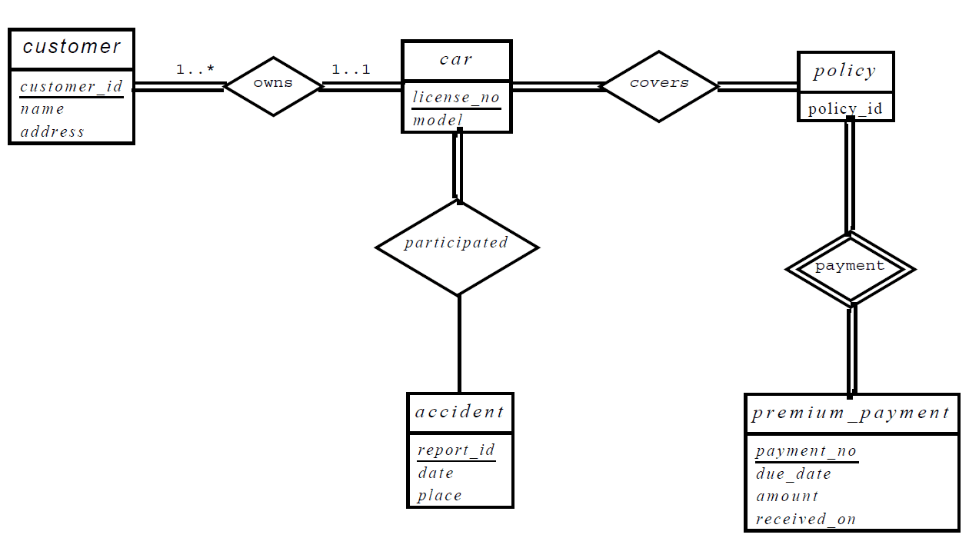

5.2 Consider a database used to record the marks that students get in different exams of different course offerings(sections).

a. Construct an E-R diagram that models exams an entities, and uses a ternary relationship, for the database.

b. Construct an alternative E-R diagram that uses only a binary relationship between *student* and *section*. Make sure that only one relationship exists between a particular *student* and *section* pair, yet you can represent the marks that a student gets in different exams.

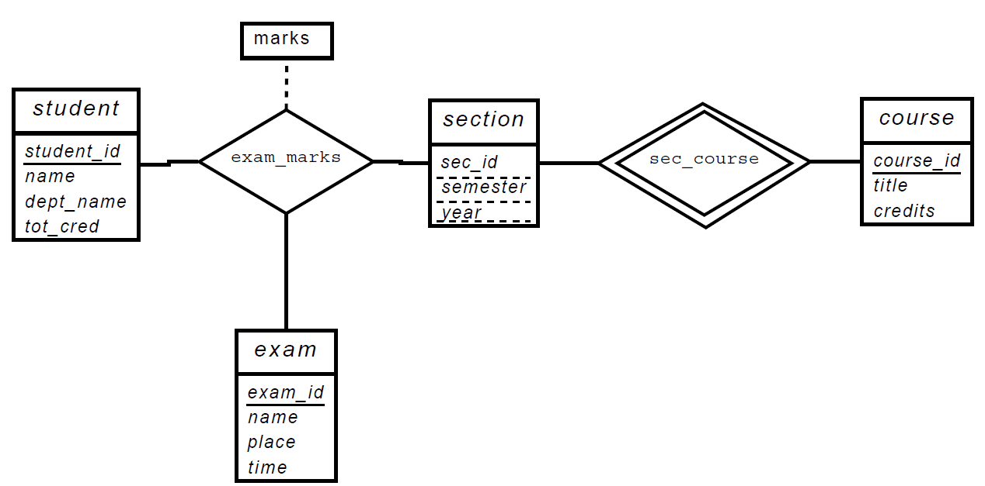

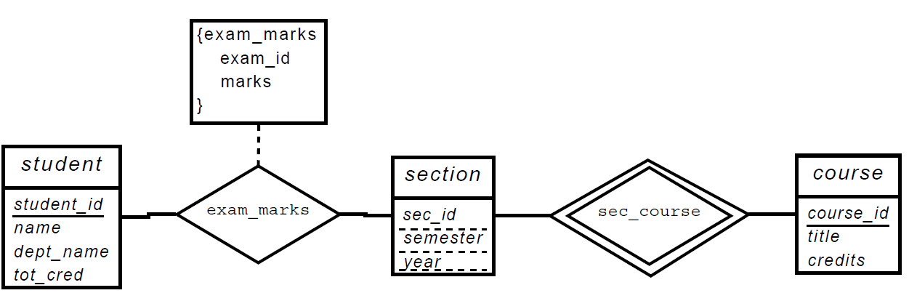

5.3 Design an E-R diagram for keeping track of the exploits of your favorite sports team. You should store the matches played, the scores in each match, the players in each match, and individual player statistics for each match. Summary statistics should be modeled as derived attributes.

